**Binary Classification and Logistic Regression**

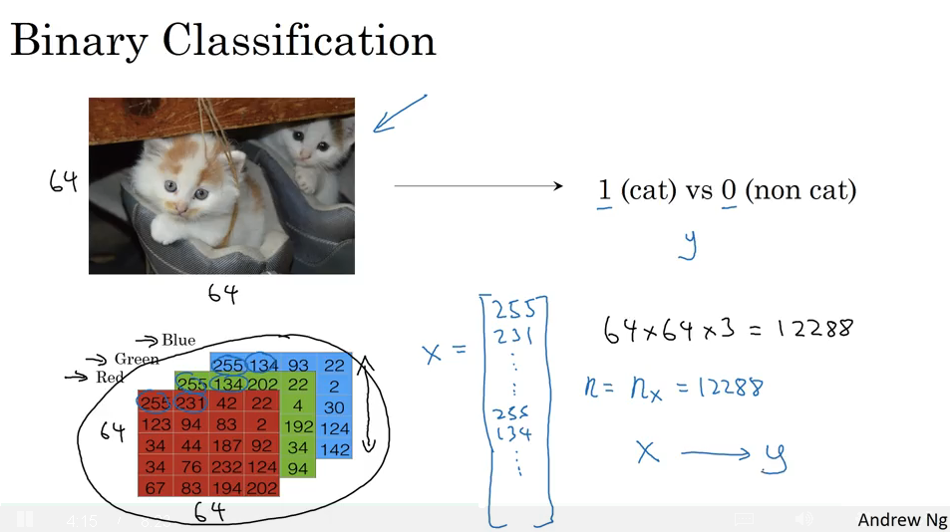

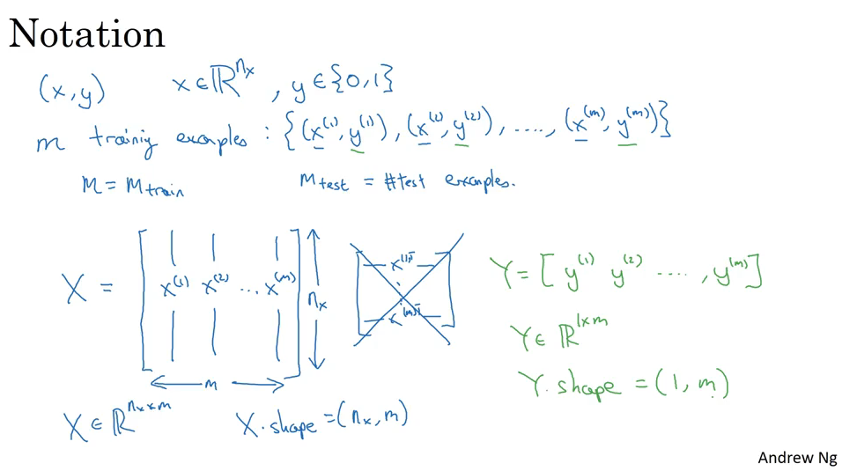

**Logistic Regression**

This is a learning algorithm that you use when the output labels Y in a supervised learning problem are all either zero or one, so for binary classification problems.

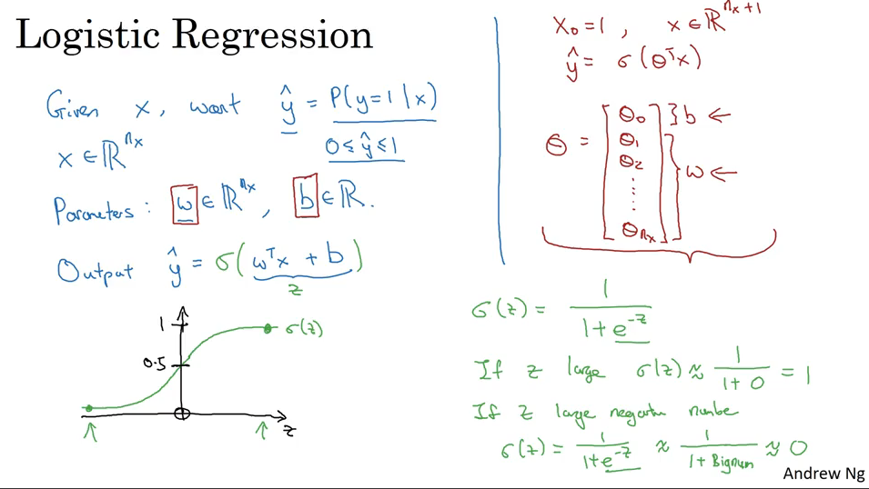

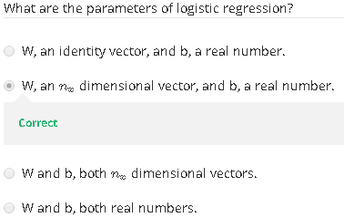

**Logistic Regression Cost Function**

